Test plan

**Test 1 – Running the GUI**

The GUI is run from the MingFortuneCookie class and is able to run without any issues.

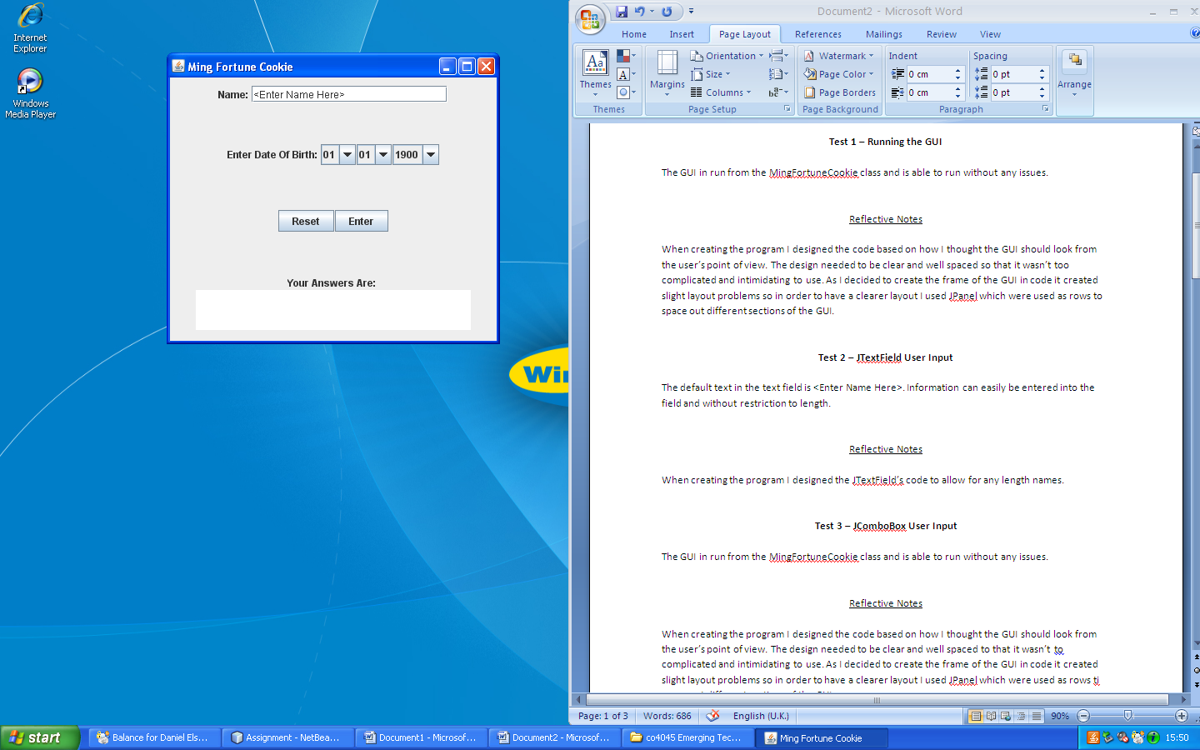

Reflective Notes

When creating the program I designed the code based on how I thought the GUI should look from the user’s point of view. The design needed to be clear and well spaced so that it wasn’t too complicated and intimidating to use. As I decided to create the frame of the GUI in code it created slight layout problems so in order to have a clearer layout I used JPanel which were used as rows to space out different sections of the GUI.

**Test 2 – JTextField User Input**

The default text in the text field is <Enter Name Here>. Information can easily be entered into the field and without restriction to length.



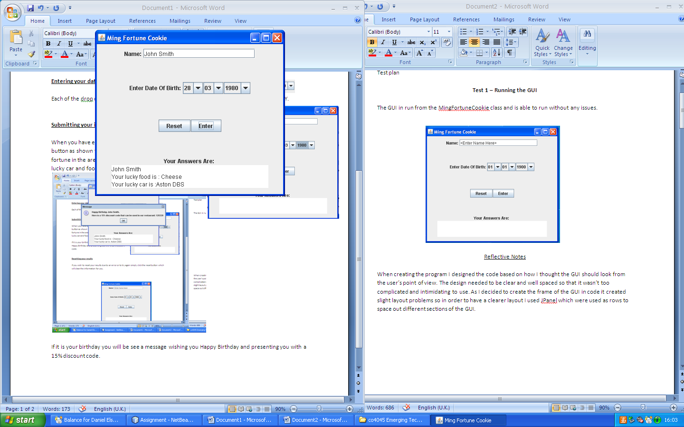

Reflective Notes

When creating the program I designed the JTextField’s code to allow for any length names.

**Test 3 – JComboBox User Input**

The JComboBoxes are work without any issues .





Reflective Notes

When creating the JComboBoxes I created each individually and linked then to and array in another class called MingEvent.

**Test 4 – JButton Action Listeners**

There are two JButtons on the GUI. The first is the enter button which when clocked worked without issues. The second is a reset button which when click returns all the fields back to default.



Reflective Notes

There are two JButtons on the GUI. The first is the Enter button which when clicked processes the user input and gives a message related the information they gave. It output the users name, their lucky food; which is chosen based of the day they input into the JComboBox and their lucky car; which is chosen based on the month they input in the JComboBox. The second is the Reset button which when clicked clears all fields and sets them all to default.

**Test 5 – JTextArea**

When the Enter button is clicked the JTextArea shows the results. This works correctly and is not editable by the user. When the Reset button is clicked the JTextArea is cleared



**Test 6 – Validation on the GUI**

The first validation on the GUI is for the JTextField which checks to see if the first character of the name is a letter works.



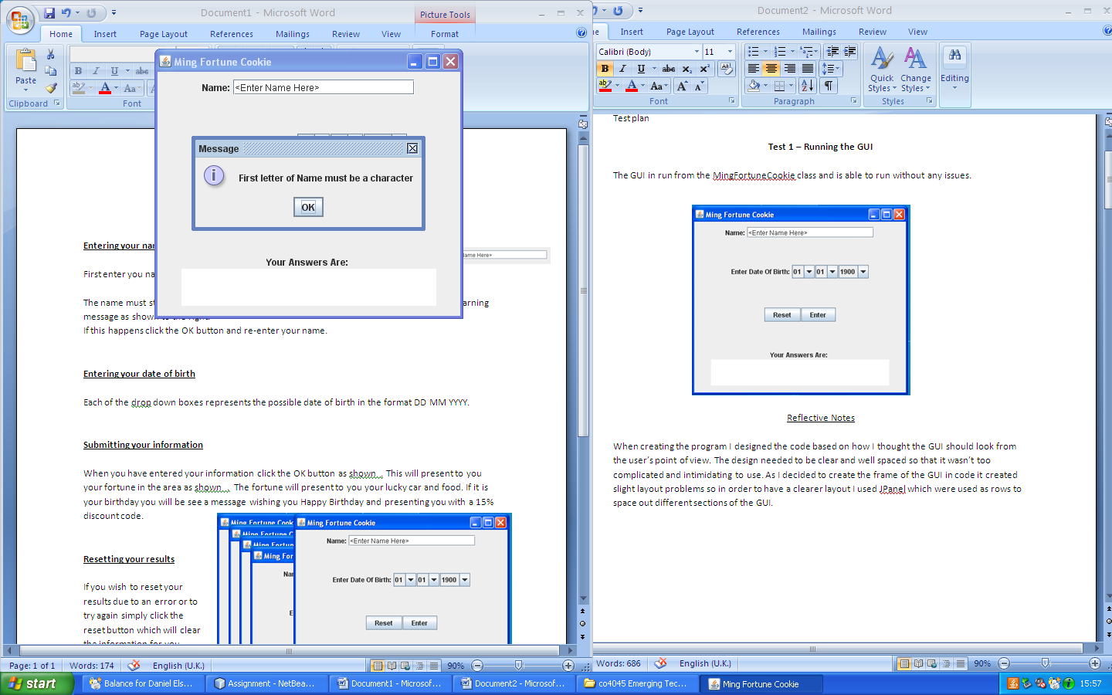

Reflective Notes

The validation for the first character of the name being a letter uses a string to match the first character to the provided letter of the alphabet.

**Test 7 – Exceptions on the GUI**

.



Reflective Notes